Chapter 10: The Environment and Change over Time Lesson 2: Biological Evidence of Evolution
Evidence of Evolution
Evidence of common ancestors can be found in the fossil record and in living organisms.
Comparative Anatomy
- The study of similarities and differences among structures of living species is called comparative anatomy.

- For example, robins, finches, and hawks have similar body parts. They all have feathers, wings, and beaks. The same is true for tigers, leopards, and house cats.

Homologous Structures
Homologous structures are body parts of organisms that are similar in structure and position but different in function.
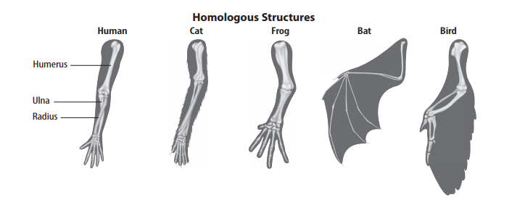
Example: The forelimbs of bats and birds are wings and are used for flying. However, the forelimb bones of all these species show similar patterns to human arms, as shown in the figure above. The forelimbs of the species in the figure are different sizes, but their placement and structure suggest common ancestry.

Analogous Structures
- Analogous structures are body parts that perform a similar function but differ in structure.
- Example: The wings in both birds and flies are used for flight. But bird wings are covered with feathers. Fly wings are covered with tiny hairs. Though used for the same function—flight—the wings of birds and insects are too different in structure to suggest close common ancestry.
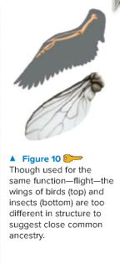
Vestigial Structures
- Vestigial structures are body parts that have lost their original function through evolution.

- Example: Ostriches have wings. Yet they cannot fly. An ostrich’s wings are an example of vestigial structures.

- The best explanation for vestigial structures is that the species with a vestigial structure is related to an ancestral species that used the structure for a specific purpose.
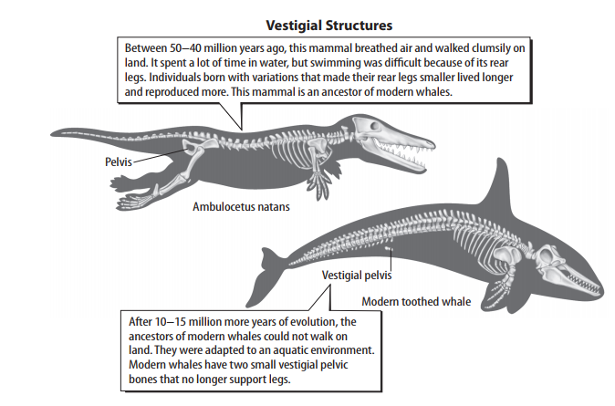

The whale shown in the figure above has tiny pelvic bones inside its body. Pelvic bones are hip bones, which in many species attach the leg bones to the body. Modern whales do not have legs. The pelvic bones in whales suggest that whales came from ancestors that used legs for walking on land. The fossil evidence supports this conclusion.

Developmental Biology
- The science of the development of embryos from fertilization to birth is called embryology.
- Studying how embryos develop can also show how species are related.
Pharyngeal Pouches
Embryos of different species often look like each other at different stages of their growth.
For example, all vertebrate embryos have pharyngeal pouches at one stage. These pouches become different body parts in each vertebrate. Yet, in all vertebrates, each part is in the face or neck.
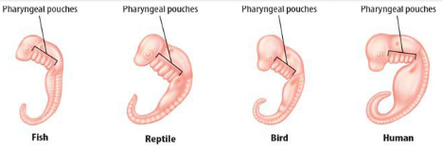
- In reptiles, birds, and humans, part of the pharyngeal pouch develops into a gland in the neck.
- This gland regulates, or balances, the body’s calcium levels. In fish, the same part becomes the gills. One function of gills is to regulate calcium.
- The similar function and location of gills and glands suggest a close evolutionary relationship between fish and other vertebrates.
Molecular Biology
Molecular biology is the study of gene structure and function.
- Discoveries in molecular biology have confirmed and extended much of the data already collected about the theory of evolution. Darwin did not know about genes, but scientists today know that mutations in genes are the source of variations upon which natural selection acts. Genes provide powerful support for evolution.
Comparing Sequences
- Scientists can study how living organisms are related by comparing their genes.
- For example, nearly all organisms have a gene for cytochrome c, a protein required for cellular respiration. Some species, such as humans and rhesus monkeys, have nearly identical cytochrome c. The more closely related two species are, the more similar their genes and proteins are.
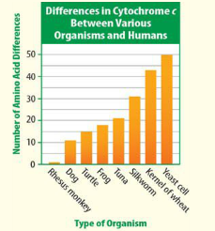
Divergence
- Scientists have found that some stretches of shared DNA mutate at regular, predictable rates.
- Scientists use this “molecular clock” to estimate when in the past living species split from common ancestors.
- Example: This is how scientists have shown that whales and porpoises are more closely related to hippopotamuses than they are to other living things. Whales and hippopotamuses share an ancestor that lived 50–60 million years ago.
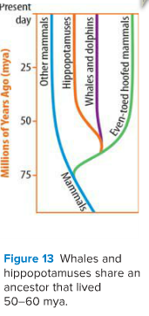
The Study of Evolution Today
- The theory of evolution by natural selection is the cornerstone of modern biology.
- Since Darwin published his theory, scientists have confirmed, refined, and extended his work.
How New Species Form
- New evidence supporting the theory of evolution by natural selection is discovered nearly every day.
- Scientists debate some of the details. The figure below shows how scientists have different ideas about the rate at which natural selection produces new species.
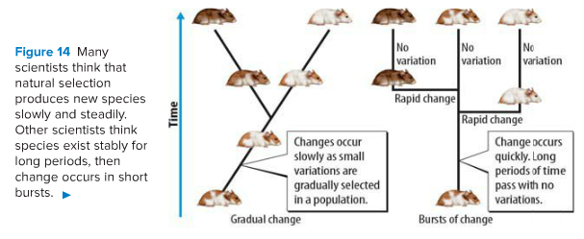
- Some say it works slowly and gradually. Others say it works quickly, in bursts.
Diversity
- Evolution has produced Earth’s wide diversity of living things using the same basic building blocks called genes.
- Scientists are finding that genes can be reorganized in simple ways and give rise to dramatic changes in organisms.
- Scientists now study evolution by looking at molecules. Yet, they still use the same basic ideas that Darwin came up with over 150 years ago.

